Experiment No. 12

Aim: Simulate working of SMTP using Cisco Packet Tracer

Theory:
- SMTP stands for Simple Mail Transfer Protocol.
- SMTP is a set of communication guidelines that allow software to transmit an electronic mail over the internet is called Simple Mail Transfer Protocol.
- It is a program used for sending messages to other computer users based on e-mail addresses.
- It provides a mail exchange between users on the same or different computers, and it also supports:
  - It can send a single message to one or more recipients.
  - Sending message can include text, voice, video or graphics.
  - It can also send the messages on networks outside the internet.
- The main purpose of SMTP is used to set up communication rules between servers. The servers have a way of identifying themselves and announcing what kind of communication they are trying to perform. They also have a way of handling the errors such as incorrect email address. For example, if the recipient address is wrong, then receiving server reply with an error message of some kind.
- Steps to configure SMTP Server on Cisco Packet Tracer:

- Take a switch
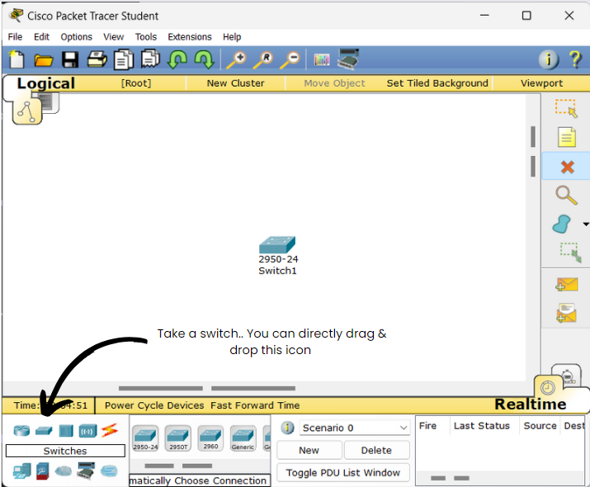

- Take 2 PC’s
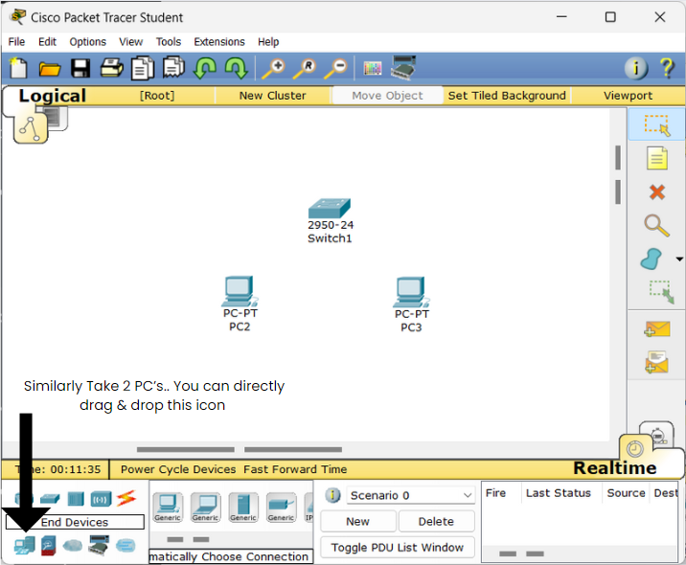

- Take 1 Server
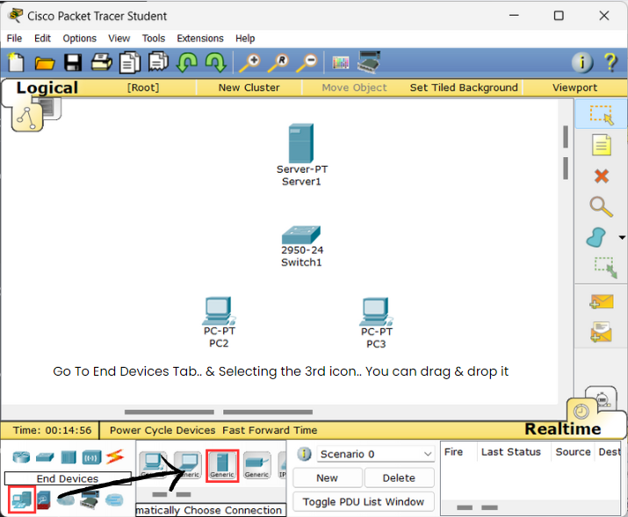

- Go to “Connections” tab.. Select the first option with the same logo as the connections tab.
Click on PC1 and then to Switch to connect PC1 to Switch.. Similarly.. Click again on the connection option > Click on PC2 > Click on Switch which connects PC2 with Switch and then do the same for the Switch and the server.
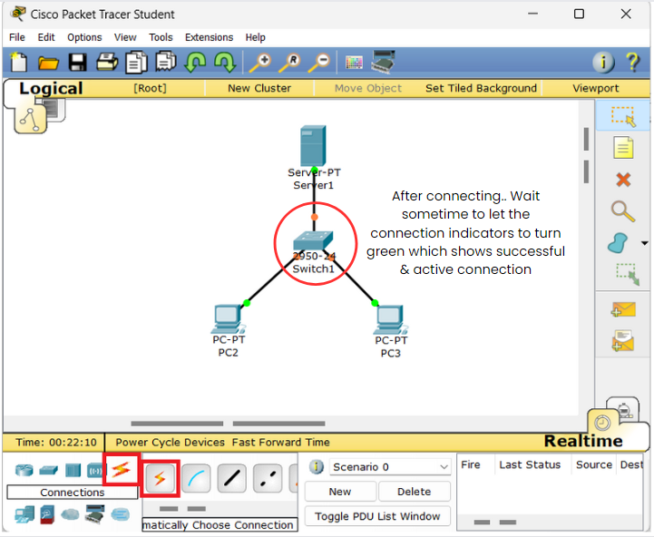

After doing so, follow the note given on right side of the switch in above image.
- Click on PC1 > Go To “Desktop” Menu option > Click on IP Configuration.
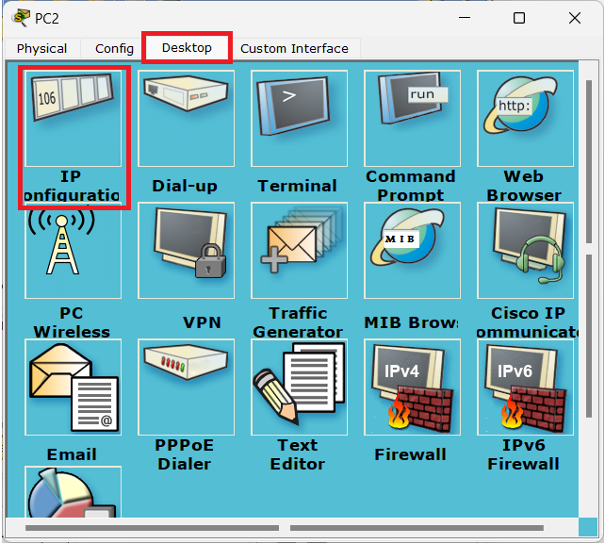

- Click on “IP Address” Text field. Give the IP to PC1 as 192.186.1.2 (You can give any usable IP Address here). When you complete the IP Address, Press “Tab” key which will auto fill the “Subnet Mask” field. Then close the window for PC2.
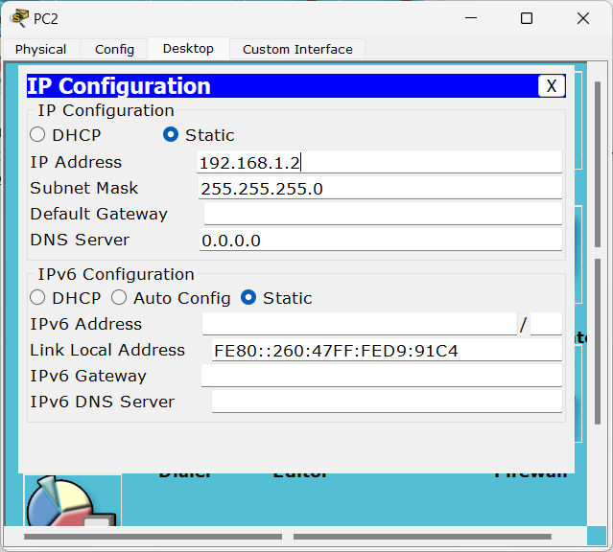

Do the same operation for PC2 but give an IP Address 192.186.1.3 to PC2 (You can give any usable IP Address)
- Click on Server. Go to Desktop Menu and then to IP Configuration tab as we did before. Here assign the IP Address to the server as 192.186.1.1 and Press Tab key to auto fill the Subnet Mask Field.
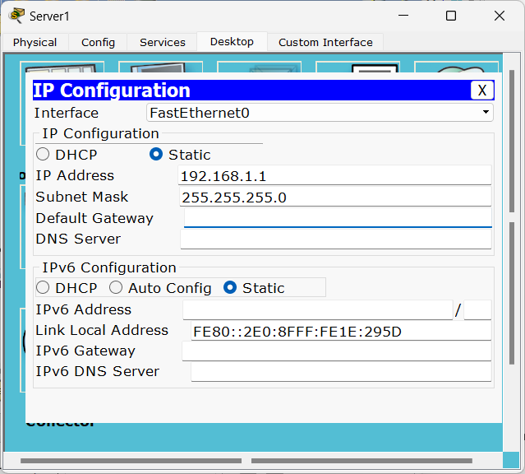

[ Note: If you have any server / router in your network, it should have the First IP Address of your IP range as it works as the Gateway ( Start / Exit ) point of your network as here we used 192.168.1.1 and rest (192.168.1.2& 192.168.1.3) to the other network nodes. ]

- Close the IP Configuration Tab and Click on “Services” Menu Option on the Left Side of Desktop Menu, Go To “Email” and make sure the SMTP and POP3 is services are “ON”.
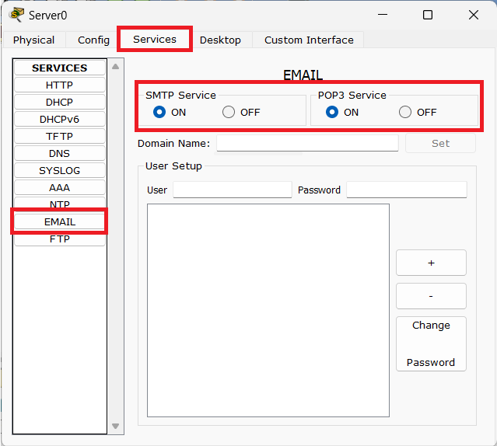

- Enter a domain name “gmail.com”. You can use any domain but it should also be used as domains for user in the SMTP / Email server.
Next Step, Create 2 users in the Email server by entering a Username and Password. Click on ‘+’ icon on right to add a user with specified name & password.
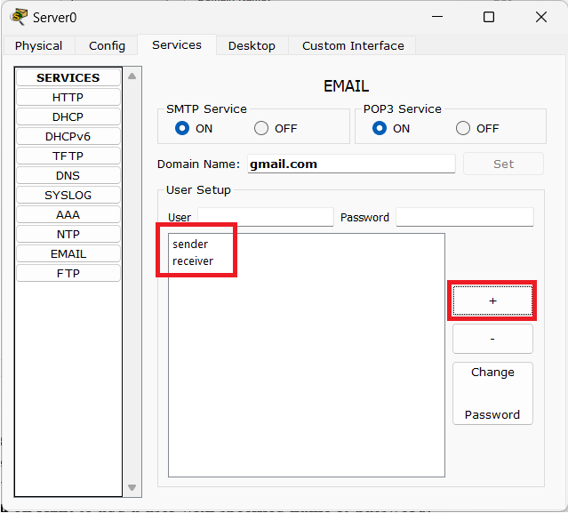

- Close the tabs and Go to PC0 > Desktop > Email.
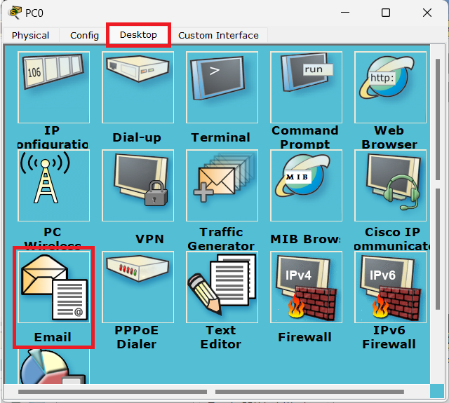

- You’ll see a “Configure Mail” window. Enter all the information as shown in the following picture
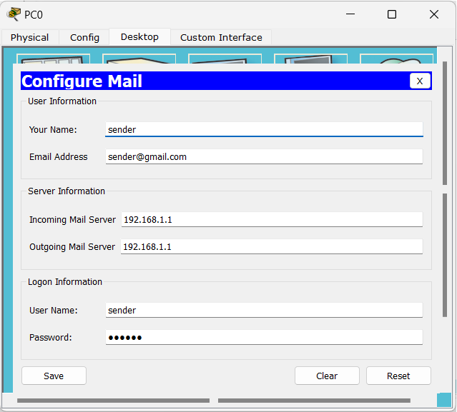

Input Details:
Your Name:[ You can put any name ]
Email Address: [Preferably use the email address as <username><domain_name> as we used sender@gmail.com in which “sender” is the username & “gmail.com” the domain name we registered on the server.]
Incoming & Outgoing Mail Server: Enter the IP Address of the Server i.e. 192.168.1.1 as we are using the same server for both sending & receiving the mails.
Username & Password: Enter the username and password of any 1 of the user you created on the mail server.

Perform the same operation on the other PC (PC1) also.
Note: Use the Name, Email address, Username and password of the 2nd user you created on the server for PC1. Keep the data format for entering the details same as specified above.
- After entering the data, you will see a dashboard of email application on the pc as show below.
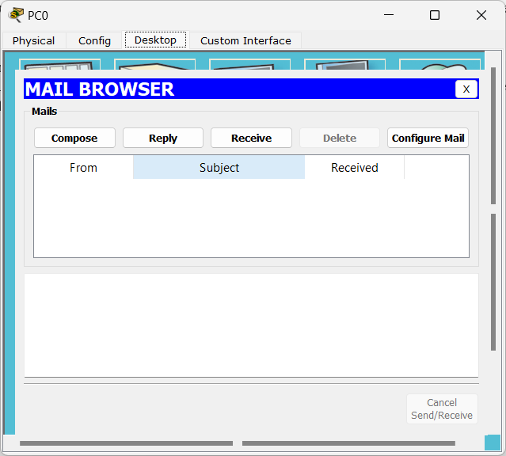

- Click on “Compose” Option. Enter email address of other user in “To” field than the one whose account is registered on the current PC. Note that we are on PC0 which was registered with “sender” user that is why we used receiver’s email id as the recipients email address.
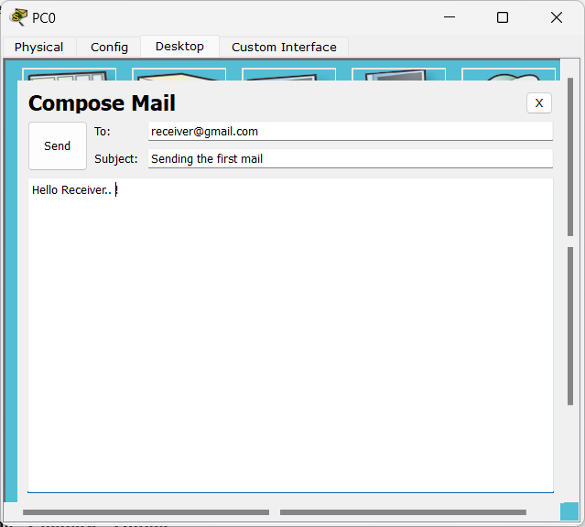

Fill the “Subject” and “Email Body” field as you want & click on “Send” button.
- After clicking on Send Button, you’ll be redirected again to the dashboard and there you can see the email status at bottom left corner of the window.
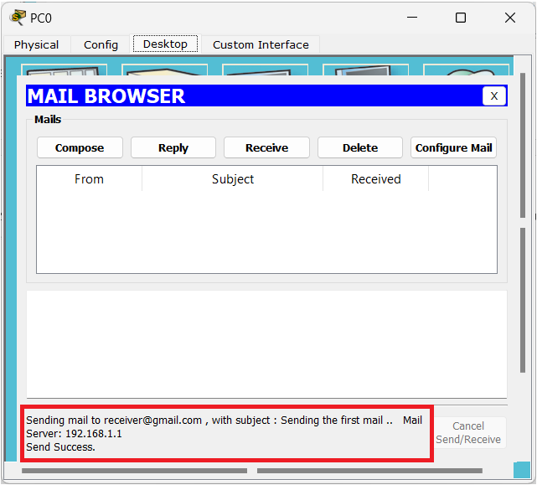

Here, the Email details will be shown with the data – receiver’s email address, subject of the mail, IP Address of the Mail server & Transmission status of email as “Send Success”.

- Close the tabs for PC0 and open the Email Application on PC1 as we did in Step 10.
When you see the email application dashboard / home page, Click on “Receive” button. The email will be fetched from the server to your client machine, as shown in the following figure.
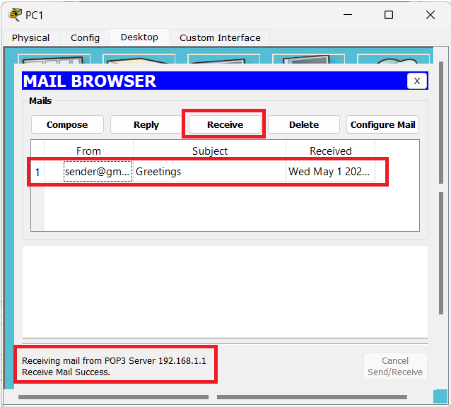

You can click on the email & read the whole email, also you can reply the email, delete the email or also compose another email for sender from receiver. (Sender and Receiver are just 2 users in this scenario not actual role of the client machine.)

Here, we have successfully configured our Email server & transmitted the emails.

Conclusion: Students are able to simulate working of SMTP using Cisco Packet Tracer.

